**Final Project Report**

**Title:**  Study of Tobacco Consumption Trends and Effects

**Team Name**: ComSem’s

**Team Member:**

Charu Arora

Josina Joy

Joydeep Roy

Manalee Panda

**Type of Project:** Custom Project

1. **Introduction**

The project aims at analyzing and understanding the data available in the following rdf datasets:

* + - <https://catalog.data.gov/dataset/youth-tobacco-survey-yts-data>
    - <https://catalog.data.gov/dataset/u-s-chronic-disease-indicators-cdi-e50c9>
    - <http://www.americashealthrankings.org/explore/2015-annual-report>

The project uses Gruff to visualize the datasets and SPARQL queries have been used to analyze the impact of tobacco in the form of cigarette smoking prevalence, cigarette smoking frequency, smokeless tobacco products use and their impact on health and chronic diseases.

1. **Target Audience**

Data Analysis of this project is useful to

1. Department of Health and Human Services (HHS)

The U.S. Department of Health and Human Services(HHS) protects the health of all Americans and provides essential human services. The results from our project can help the HHS to arrive at conclusions regarding how tobacco use impacts the overall health ranking of various states. It will also help the HHS to create targeted campaigns aimed at the population groups whose health is being adversely impacted by the consumption of tobacco products.

1. General population

The results from our project showcase the adverse effects of Tobacco consumption on Health to the General Population.

1. **Description of Data Sources**

The datasets used for this project are:

1. Dataset 1 - Youth Tobacco Survey:

* It gives comprehensive data on both middle school and high school students regarding tobacco use, exposure to environmental tobacco smoke, smoking cessation
* Some important properties defined in dataset are Gender, Education, Data-Value, Topic, LocationDesc

1. Dataset 2 – US Chronic Disease Indicators:

* It provides indicators like tobacco use that were developed by consensus and that allows states and territories and large metropolitan areas to uniformly define, collect, and report chronic disease data that are important to public health practice and available for states, territories and large metropolitan areas.
* Properties defined in dataset are Questions, LocationDesc, TopicDesc, Data Value, Data Value Type

1. Dataset 3 – US Chronic Disease Indicators:

* It provides the overall health ranking of all the states in the US
* Properties defined in dataset are State_Name and Rank

1. **Data Integration**

**4.1 The datasets were visualized and analyzed using Gruff as follows :**

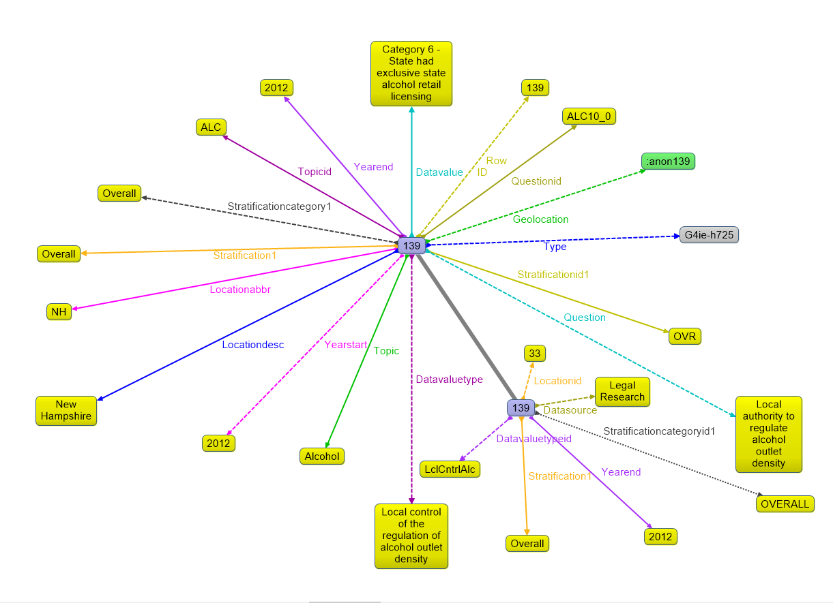

*Graph visualization of Chronic Disease dataset*

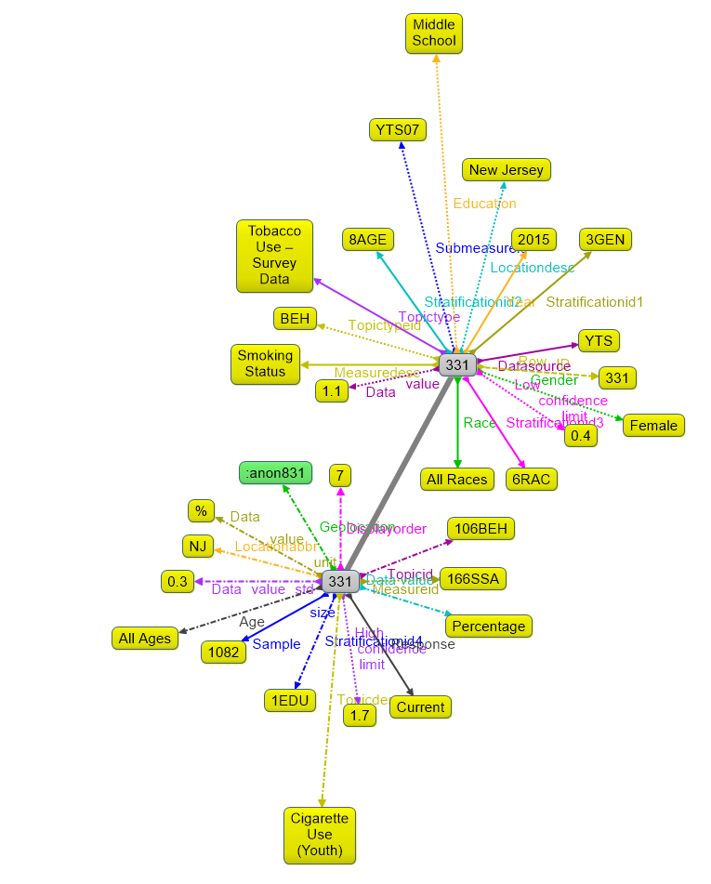

*Graph visualization of Youth Tobacco Survey dataset*

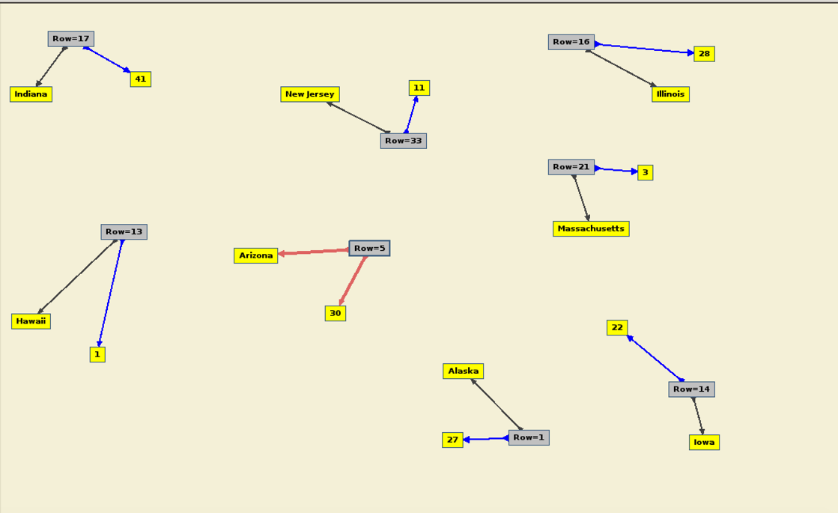

*Graph visualization of Health Rankings dataset*

**4.2 Steps in data integration:**

1. First we loaded the 3 datasets in apache-jena-fuseki server
2. SPARQL query was generated on Dataset 1 to depict the smoking trends in Male, Female, Middle School and High School
3. SPARQL query was generated on Dataset 2 to analyze the smoking trends in the different states in the USA
4. SPARQL query was generated to compare the percentage of youth consuming tobacco and the total population of tobacco consumption in 14 different states in the USA. Dataset 1 and Dataset 2 were integrated for this purpose and ‘LocationDesc’ was the common value which was used to integrate.
5. In comparative analysis we analyzed how the number of cigarette packages sold in each state affects the health rank of the states. Dataset 2 and Dataset 3 were integrated for this purpose and ‘LocationDesc/State_Name’ was the common value which was used to integrate.

A visual representation of the values of integration:

|  |  |  |  |  |
| --- | --- | --- | --- | --- |
| DATASET 1 | | | | |
| LocationDesc | Gender | Education | Data Value | Topic |

|  |  |  |  |  |
| --- | --- | --- | --- | --- |
| DATASET 2 | | | | |
| LocationDesc | Questions | TopicDesc | Data Value | Data Value Type |

|  |  |
| --- | --- |
| DATASET 3 | |
| State_Name | Rank |

1. **Data Product Results**
2. From the study of tobacco consumption trends, we see that among the males in middle school and high school, 76.1% are in Cessation while 13.8 % use cigarette and 10.1% use smokeless tobacco. As compared to the males in middle school and high school, less number of females use cigarette and smokeless tobacco and about an 83.1% are in Cessation. This result is shown in the following two graphs :

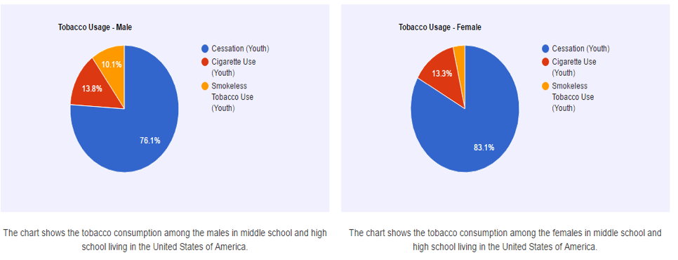

Fig. : Tobacco use -Male and Female in Middle school and High school

1. The next comparison is in between the students in middle school and high school. From the charts below, we see that there are 89.2% of youth in Cessation in middle school while the Cessation in high school in 72%. There are more percentage of students in high school who use cigarette and smokeless tobacco than in middle school.

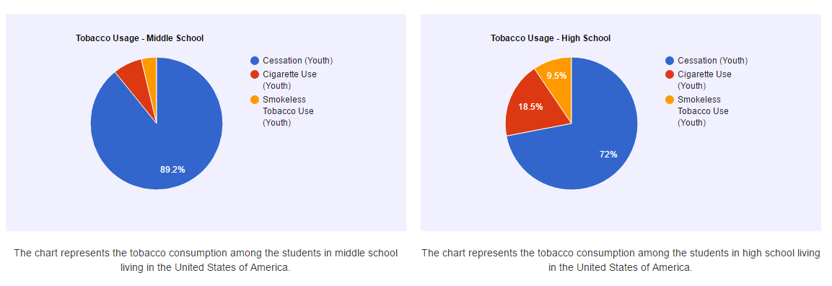

Fig.: Tobacco consumption trends among students in middle school and high school

1. The next comparison is between the tobacco consumption among youth and tobacco consumption among total population in 14 states. From the graph we see that in some states like ‘Utah’, the tobacco consumption by youth is very minimal compared to the overall consumption while in other states like ‘Georgia’, the youth make up for around one-third of the total consumption.

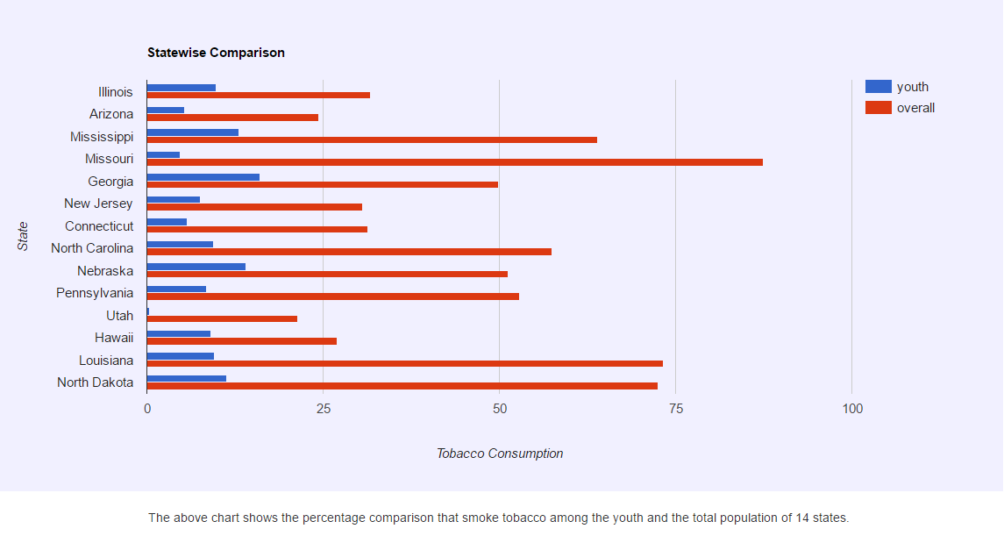

Fig.: Statewise comparison of tobacco consumption in youth and total population

1. The next comparison is between the Health Rank in states of USA and the sale of cigarette packets among the states. From the two maps, we can conclude that the states with highest number of cigarette packets sold are the ones with poor health ranks.

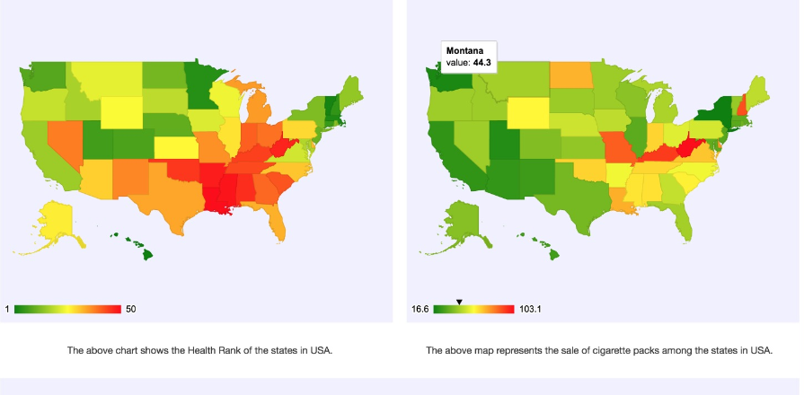

Fig.: Maps showing Health Rank of states and cigarette packets sold in the states

1. Also, by clicking on each state on a map, we can get a visualization of the tobacco consumption trends among various population groups in that state as shown in the following figure.

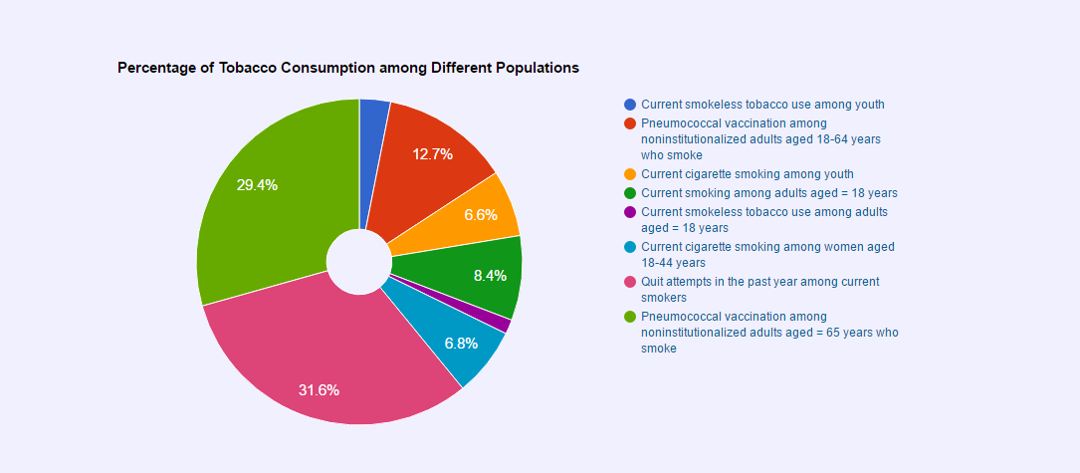

Fig.: Tobacco consumption trends in different population groups

1. **Custom Project Justification**

This project is different from the simple projects as we had to set up SPARQL endpoints.

We used apache-jena-fuzeki server to load out datasets and set up the SPARQL endpoints.

1. **Summary**

In this project, we have understood and analyzed the three datasets. We visualized the data using Gruff and generated SPARQL queries on the datasets to compare the tobacco consumption trends in various population groups in the states of USA. Also, we compared the number of cigarette packets sold in every state with the Health Rank of each state. The end results of our project will be helpful to the Department of Health and Human services and also to the general population. It will make our target audience aware of the general trends in tobacco use among various population groups and also how cigarette use impacts the overall health ranking of the states. It will also help the HHS to create targeted campaigns aimed at the population groups whose health is being adversely impacted by the consumption of tobacco products.